**EXPERIMENT-4**

**theHarvester**

**AIM:**

To demonstrate information gathering using theHarvester.

**PROCEDURE:**

* **Open terminal in the kali linux.**
* **Run the following command.**
* **Command:**

**theHarvester-d[www.zoho.com](http://www.zoho.com/)-l300-ball.**

* Run this command“**theHarvester-d**[**www.zoho.com**](http://www.zoho.com/)**-l300-ball-ftest”and**hitenterto export the result as html file and xml file.
* Now close the terminal and navigate the home folder and search for test file .

**OUTPUT:**

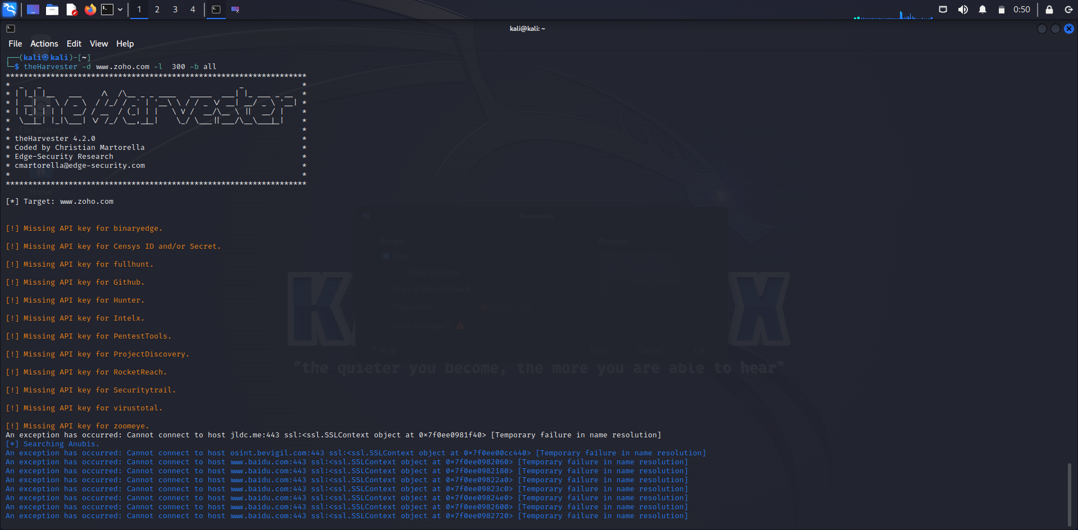

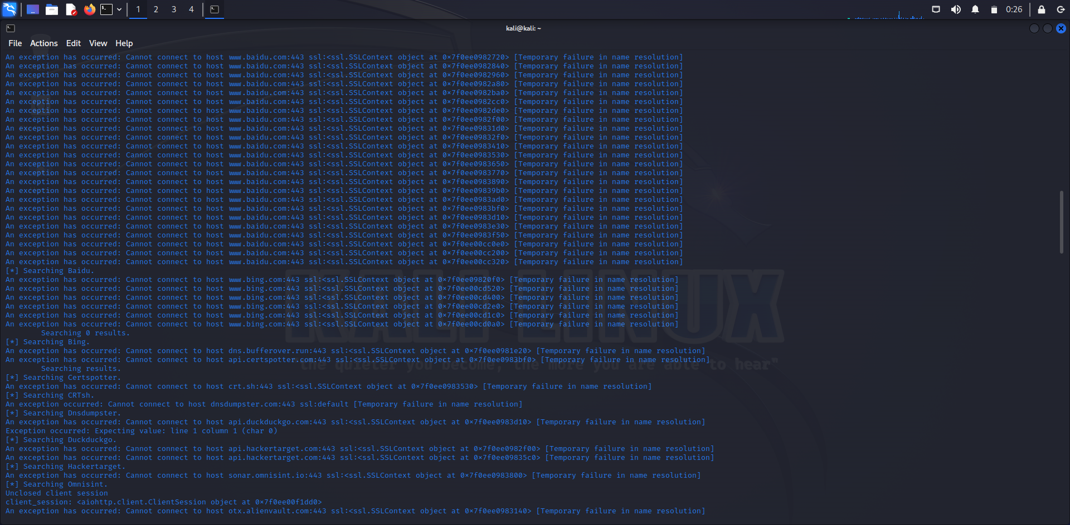

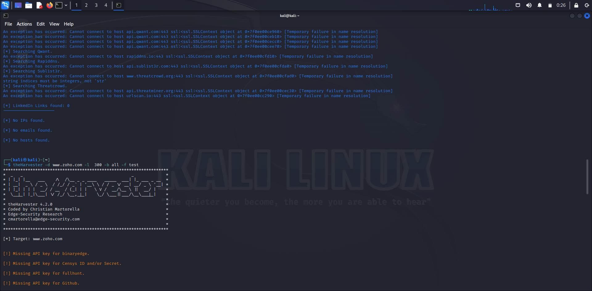

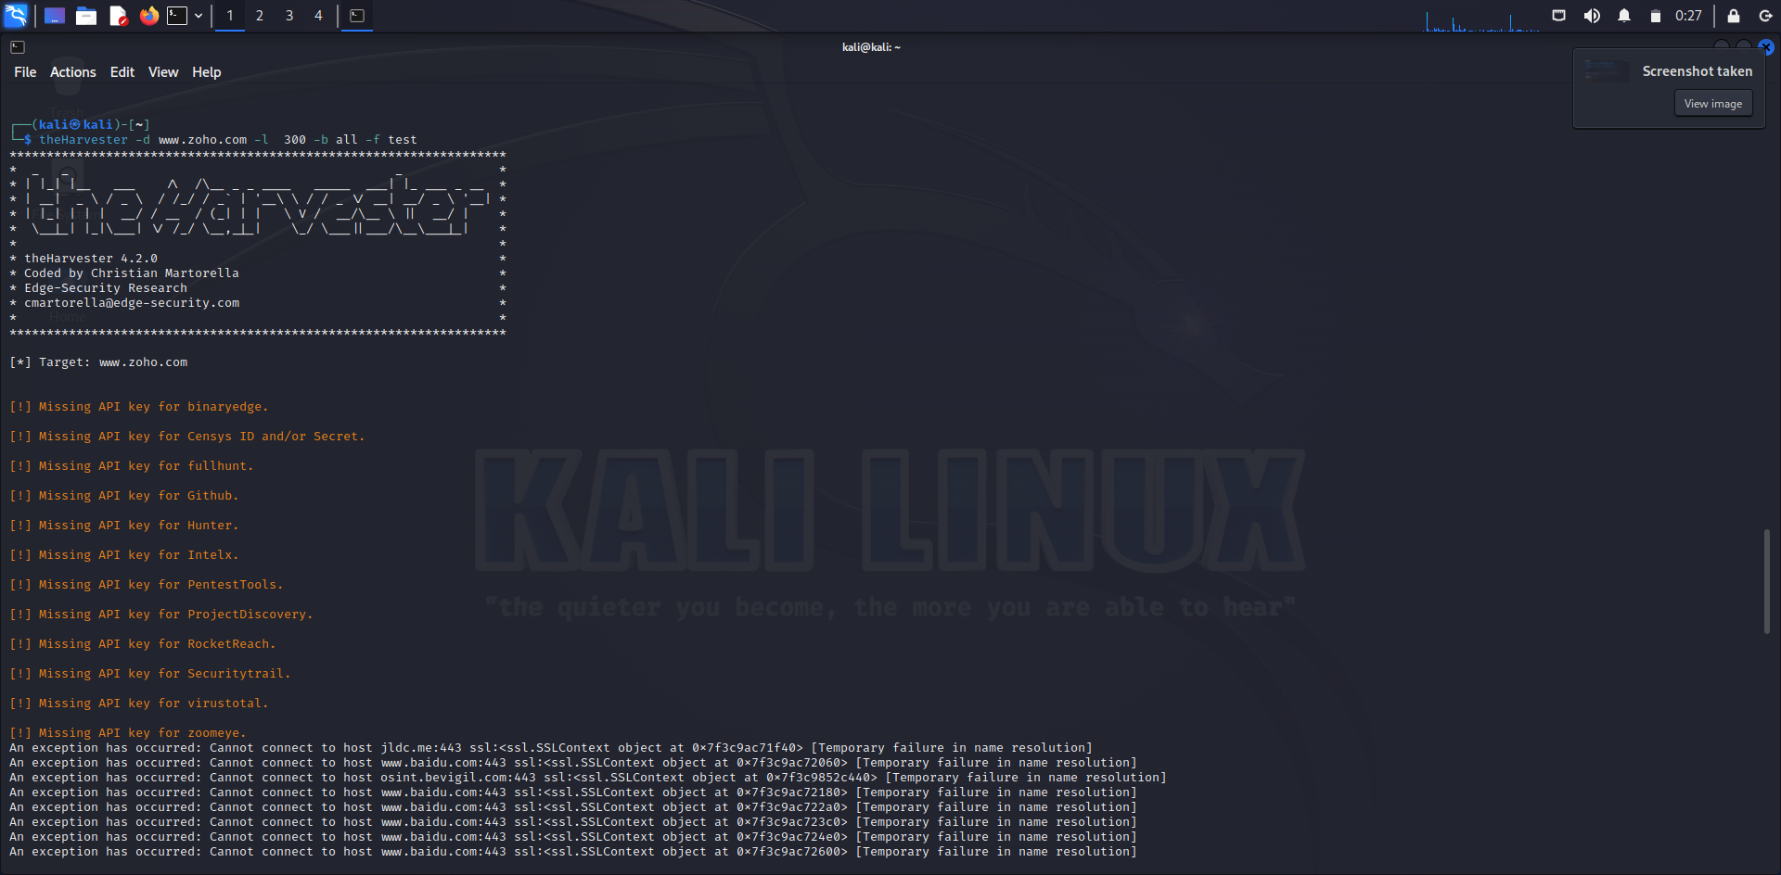

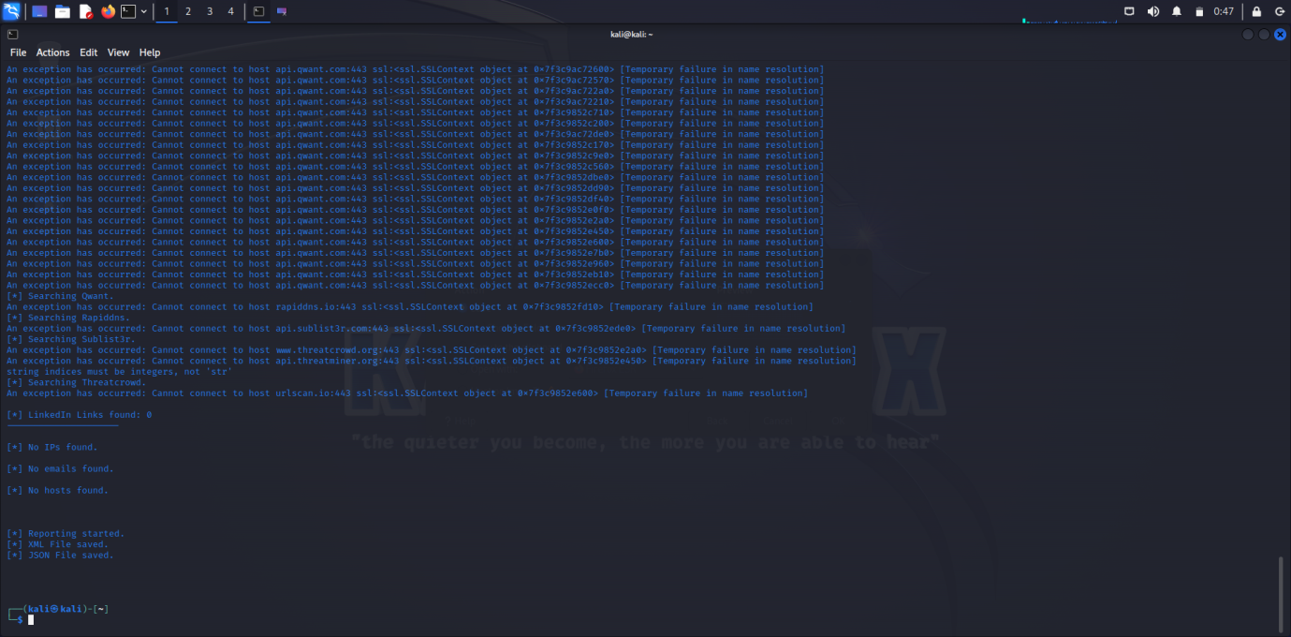

**RESULT:**

Gathering the information using theHarvester.